Computing and Culture Design Doc for Project 2026
Game Design

Overview of the Game
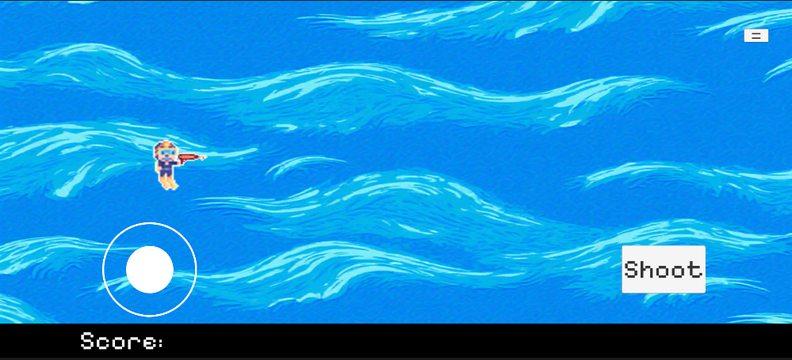
Figure 1: Concept
The name of my game is ‘H2O(h) No!’. It will be based on SDG 14, Life Below Water.
Core Concept
My game is a 2D underwater side scroller where the player moves using touch input and must avoid and destroy various hazards. As it aims to teach about SDG14, the game takes place under the sea, where the player is attacked by many different enemies that are harmful to the ocean. There will be 3 levels to the game, in each the player must defeat a unique boss.
Target Audience
The target audience for my game will mainly be for lower secondary school students as the game will be slightly challenging. This will be because the player is eliminated after taking a single hit.
Platforms
My game will be a mobile game and will be created using the Unity game engine version 2022.3.60f.
Intended Impact
My game is intended to teach a lesson to the user of the importance of cleaning the ocean by destroying hazards to marine life. The aim is to entice users to help stop pollution and portray how it is harming the world’s oceans.
Chosen SDG and Overview
For my game, I chose to use SDG 14: Life Below Water. SDG 14 focuses on conserving and sustainably using the world’s oceans, seas, and marine resources. The goal addresses major issues such as marine pollution, overfishing, and the destruction of marine ecosystems. SDG 14 aims to protect biodiversity, support sustainable fishing practices, and ensure clean oceans, all of which are essential for global food security, climate regulation, and the livelihoods of millions of people worldwide.
Game Concept - Genre, Who is the player, Narrative, Player Experience
My game is a 2D underwater side scroller where the player controls a diver using touch input who must avoid and destroy various ocean hazards using a gun that shoots bubbles. The game takes place under the sea, where the player is attacked by many different enemies that are harmful to the ocean. There will be 3 levels to the game, in each the player must defeat a unique boss. The narrative for the game is that the player is cleaning the ocean of hazards. The 3 levels will be split into different hazard types: level 1 will be about rubbish, with enemies looking like plastic bottles ect. Level 2 will be about oil spills, enemies appearing as dark clouds in the water. The final level will be about overfishing, the enemies appearing has fishhooks.

Low Level Prototype
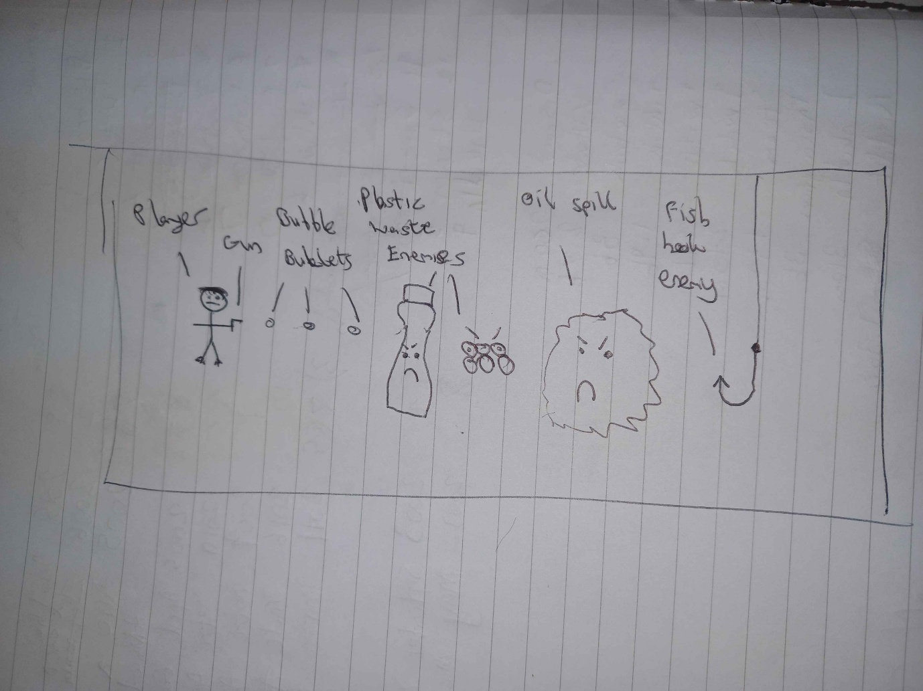
Figure 2: Hand drawn prototype
Figure 2 shows the hand-drawn prototype I made for my game. It depicts the player on the left holding a gun that can shoot bubbles. Then, I’ve shown my idea for how my enemies will look. These ideas are plastics waste enemies, oil spill enemies that appear as dark clouds, and a fishhook enemy.

